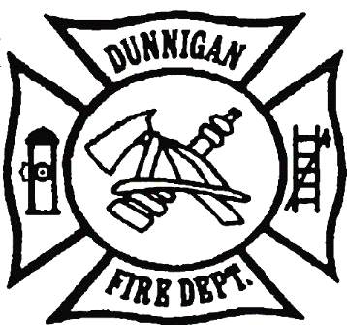COMMISSIONERS FIRE CHIEF

Anita Tatum- Chairman David Garrison

Neil Busch

Tim Hornbuckle SECRETARY

John Reyes Sherrill Jenkins

Matt Cotter

DUNNIGAN FIRE PROTECTION DISTRICT BOARD OF COMMISSIONERS

AGENDA & SUPPORTING MATERIALS

Fire Station Training Hall

July 17, 2025

6:30 P.M- Call to Order

1. Pledge of Allegiance
2. Approval of Agenda
   * Approve the June 12th meeting agenda.
3. Public Comments

* Opportunity for members of the public to address the Board of Commissioners on subjects relating to District business. The Board of Commissioners reserves the right to impose a reasonable limit on time afforded to any topic or to any individual speaker. State law prohibits action by the board on items not on the agenda.

1. Public Correspondence/ Discussion about correspondence received-

1. Approval of the May 9th meeting minutes.

1. Approval of the bills submitted for payment.
2. Reports, Discussion and Action Items from the District Fire Chief
3. Chief’s Report
4. Action Items and Reports from Board of Commissioners
5. Update on proposed CFD, CSA, CSD, or other “New Development” agreements.
   * Discussion/questions about financial forecast document below. Request from Chief Garrison for a letter to be sent to the Board of Supervisors with attached Cost/Income analysis to voice concerns about the viability of the District.



1. Budget Status update and any concerns
   * + - Discussion on approval of budget adjustments for FY 2024-25

Approve the following adjustment to the FY 2024-25 annual budget to correct over drafted accounts:



* + - Discussion and approval of the Fiscal Year 2025-26 annual budget-

1. Update on the new septic system- Chief Garrison/Hornbuckle
2. **CLOSED SESSION -** 
   * + Personnel Issue- Pursuant to Government Code Section (§54957 (b) (1))
3. **RECONVENE OPEN MEETING**
   * + - Public report of any actions taken during closed session.
4. MOTION TO ADJOURN - The next regular meeting will be held on August 14th at the Fire Station Training Hall.